WEEK 4 HANDS ON

1.Spring-rest Hands on

**Hands on 1**

**Create a Spring Web Project using Maven**

1. Go to <https://start.spring.io/>
2. Change Group as “com.cognizant”
3. Change Artifact Id as “spring-learn”
4. Select Spring Boot DevTools and Spring Web
5. Create and download the project as zip
6. Extract the zip in root folder to Eclipse Workspace
7. Build the project using ‘mvn clean package -Dhttp.proxyHost=proxy.cognizant.com -Dhttp.proxyPort=6050 -Dhttps.proxyHost=proxy.cognizant.com -Dhttps.proxyPort=6050 -Dhttp.proxyUser=123456’ command in command line
8. Import the project in Eclipse "File > Import > Maven > Existing Maven Projects > Click Browse and select extracted folder > Finish"
9. Include logs to verify if main() method of SpringLearnApplication.
10. 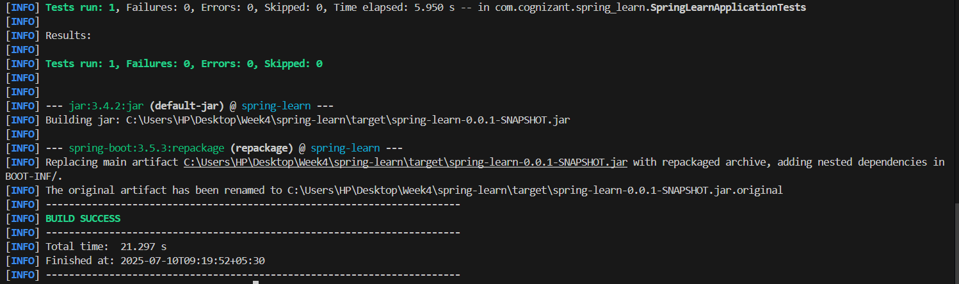Run the SpringLearnApplication class.

**Hands on 4**

**Spring Core – Load Country from Spring Configuration XML**

package com.cognizant.spring_learn;

import org.slf4j.Logger;

import org.slf4j.LoggerFactory;

public class Country {

    private static final Logger LOGGER = LoggerFactory.getLogger(Country.class);

    private String code;

    private String name;

    public Country() {

        LOGGER.debug("Inside Country Constructor.");

    }

    public String getCode() {

        LOGGER.debug("Inside getCode.");

        return code;

    }

    public void setCode(String code) {

        LOGGER.debug("Inside setCode.");

        this.code = code;

    }

    public String getName() {

        LOGGER.debug("Inside getName.");

        return name;

    }

    public void setName(String name) {

        LOGGER.debug("Inside setName.");

        this.name = name;

    }

    @Override

    public String toString() {

        return "Country [code=" + code + ", name=" + name + "]";

    }

}

package com.cognizant.spring_learn;

import org.slf4j.Logger;

import org.slf4j.LoggerFactory;

import org.springframework.context.ApplicationContext;

import org.springframework.context.support.ClassPathXmlApplicationContext;

public class SpringLearnApplication {

    private static final Logger LOGGER = LoggerFactory.getLogger(SpringLearnApplication.class);

    public static void main(String[] args) {

        LOGGER.debug("START");

        displayCountry();

        LOGGER.debug("END");

    }

    public static void displayCountry() {

        ApplicationContext context = new ClassPathXmlApplicationContext("country.xml");

        Country country = context.getBean("country", Country.class);

        LOGGER.debug("Country : {}", country.toString());

    }

}

<?xml version="1.0" encoding="UTF-8"?>

<beans xmlns="http://www.springframework.org/schema/beans"

    xmlns:xsi="http://www.w3.org/2001/XMLSchema-instance"

    xsi:schemaLocation="

        http://www.springframework.org/schema/beans

        https://www.springframework.org/schema/beans/spring-beans.xsd">

    <bean id="country" class="com.cognizant.spring_learn.Country">

        <property name="code" value="IN" />

        <property name="name" value="India" />

    </bean>

</beans>

<?xml version="1.0" encoding="UTF-8"?>

<configuration>

    <appender name="STDOUT" class="ch.qos.logback.core.ConsoleAppender">

        <encoder>

            <pattern>%d{yyyy-MM-dd HH:mm:ss} %-5level %logger{36} - %msg%n</pattern>

        </encoder>

    </appender>

    <!-- Root logger at DEBUG level -->

    <root level="DEBUG">

        <appender-ref ref="STDOUT" />

    </root>

</configuration>

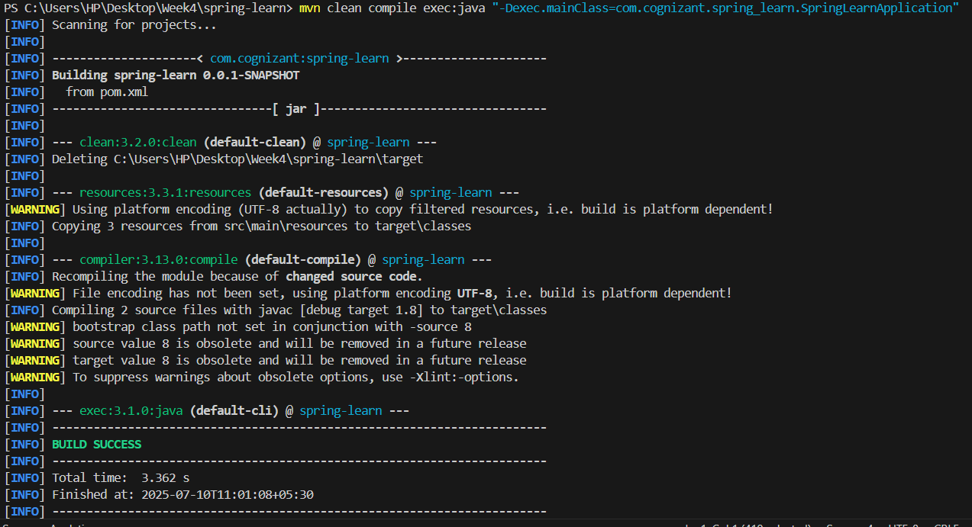Output

**Hands on 2**

**Spring Core – Load SimpleDateFormat from Spring Configuration XML**

<?xml version="1.0" encoding="UTF-8"?>

<beans xmlns="http://www.springframework.org/schema/beans"

    xmlns:xsi="http://www.w3.org/2001/XMLSchema-instance"

    xsi:schemaLocation="

        http://www.springframework.org/schema/beans

        https://www.springframework.org/schema/beans/spring-beans.xsd">

    <!-- Define a SimpleDateFormat bean with pattern dd/MM/yyyy -->

    <bean id="dateFormat" class="java.text.SimpleDateFormat">

        <constructor-arg value="dd/MM/yyyy" />

    </bean>

</beans>

package com.cognizant.spring_learn;

import org.slf4j.Logger;

import org.slf4j.LoggerFactory;

import org.springframework.context.ApplicationContext;

import org.springframework.context.support.ClassPathXmlApplicationContext;

import java.text.ParseException;

import java.text.SimpleDateFormat;

import java.util.Date;

public class SpringLearnApplication {

    private static final Logger LOGGER = LoggerFactory.getLogger(SpringLearnApplication.class);

    public static void main(String[] args) throws ParseException {

        LOGGER.info("START");

        displayDate();

        LOGGER.info("END");

    }

    public static void displayDate() throws ParseException {

        LOGGER.info("START displayDate()");

        // Load the Spring context from date-format.xml

        ApplicationContext context = new ClassPathXmlApplicationContext("date-format.xml");

        // Get the SimpleDateFormat bean

        SimpleDateFormat format = context.getBean("dateFormat", SimpleDateFormat.class);

        // Parse the date string

        Date date = format.parse("31/12/2018");

        // Display the parsed date

        System.out.println("Parsed Date: " + date);

        LOGGER.info("END displayDate()");

    }

}

Output

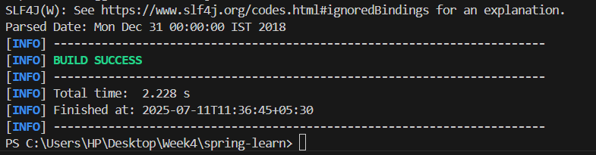

**Hands on 3**

**Spring Core - Incorporate Logging** 

<project xmlns="http://maven.apache.org/POM/4.0.0"

        xmlns:xsi="http://www.w3.org/2001/XMLSchema-instance"

        xsi:schemaLocation="

        http://maven.apache.org/POM/4.0.0

        http://maven.apache.org/xsd/maven-4.0.0.xsd">

<modelVersion>4.0.0</modelVersion>

<groupId>com.cognizant</groupId>

<artifactId>spring-learn</artifactId>

<version>0.0.1-SNAPSHOT</version>

<dependencies>

    <!-- Spring Context Core -->

    <dependency>

    <groupId>org.springframework</groupId>

    <artifactId>spring-context</artifactId>

    <version>5.3.32</version>

    </dependency>

    <!-- SLF4J API -->

    <dependency>

    <groupId>org.slf4j</groupId>

    <artifactId>slf4j-api</artifactId>

    <version>2.0.13</version>

    </dependency>

    <!-- Logback Classic binding for SLF4J -->

    <dependency>

    <groupId>ch.qos.logback</groupId>

    <artifactId>logback-classic</artifactId>

    <version>1.4.14</version>

    </dependency>

</dependencies>

<build>

    <plugins>

    <!-- Exec Maven Plugin -->

    <plugin>

        <groupId>org.codehaus.mojo</groupId>

        <artifactId>exec-maven-plugin</artifactId>

        <version>3.1.0</version>

        <configuration>

        <mainClass>com.cognizant.spring_learn.SpringLearnApplication</mainClass>

        </configuration>

    </plugin>

    </plugins>

</build>

</project>

<?xml version="1.0" encoding="UTF-8"?>

<beans xmlns="http://www.springframework.org/schema/beans"

    xmlns:xsi="http://www.w3.org/2001/XMLSchema-instance"

    xsi:schemaLocation="http://www.springframework.org/schema/beans

        https://www.springframework.org/schema/beans/spring-beans.xsd">

    <bean id="dateFormat" class="java.text.SimpleDateFormat">

        <constructor-arg value="dd/MM/yyyy" />

    </bean>

</beans>

# Log levels

logging.level.org.springframework=info

logging.level.com.cognizant.spring_learn=debug

# Log output pattern: Date|Time|Thread|Level|Logger|Method|Message

logging.pattern.console=%d{yyMMdd}|%d{HH:mm:ss.SSS}|%-20.20thread|%5p|%-25.25logger{25}|%25M|%m%n

package com.cognizant.spring_learn;

import java.text.ParseException;

import java.text.SimpleDateFormat;

import java.util.Date;

import org.slf4j.Logger;

import org.slf4j.LoggerFactory;

import org.springframework.context.ApplicationContext;

import org.springframework.context.support.ClassPathXmlApplicationContext;

public class SpringLearnApplication {

    // Add Logger instance

    private static final Logger LOGGER = LoggerFactory.getLogger(SpringLearnApplication.class);

    public static void main(String[] args) {

        SpringLearnApplication app = new SpringLearnApplication();

        app.displayDate();

    }

    public void displayDate() {

        LOGGER.info("START");

        ApplicationContext context = new ClassPathXmlApplicationContext("date-format.xml");

        SimpleDateFormat format = context.getBean("dateFormat", SimpleDateFormat.class);

        try {

            Date parsedDate = format.parse("31/12/2018");

            LOGGER.debug("Parsed Date: {}", parsedDate);

        } catch (ParseException e) {

            LOGGER.error("Error parsing date", e);

        }

        LOGGER.info("END");

    }

}

Output

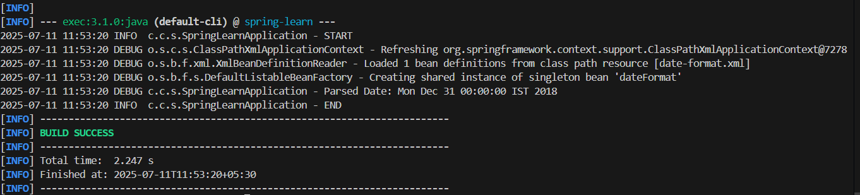

**Hands on 5**

**Spring Core – Demonstration of Singleton Scope and Prototype Scope**

<?xml version="1.0" encoding="UTF-8"?>

<beans xmlns="http://www.springframework.org/schema/beans"

    xmlns:xsi="http://www.w3.org/2001/XMLSchema-instance"

    xsi:schemaLocation="

        http://www.springframework.org/schema/beans

        https://www.springframework.org/schema/beans/spring-beans.xsd">

    <bean id="country" class="com.cognizant.spring_learn.Country">

        <property name="code" value="IN"/>

        <property name="name" value="India"/>

    </bean>

</beans>

package com.cognizant.spring_learn;

public class Country {

    private String code;

    private String name;

    public Country() {

        System.out.println("Country Bean Constructor Called");

    }

    public String getCode() { return code; }

    public void setCode(String code) { this.code = code; }

    public String getName() { return name; }

    public void setName(String name) { this.name = name; }

    @Override

    public String toString() {

        return "Country [code=" + code + ", name=" + name + "]";

    }

}

package com.cognizant.spring_learn;

import org.slf4j.Logger;

import org.slf4j.LoggerFactory;

import org.springframework.context.ApplicationContext;

import org.springframework.context.support.ClassPathXmlApplicationContext;

public class SpringLearnApplication {

    private static final Logger LOGGER = LoggerFactory.getLogger(SpringLearnApplication.class);

    public static void main(String[] args) {

        displayCountry();

    }

    public static void displayCountry() {

        LOGGER.info("START");

        ApplicationContext context = new ClassPathXmlApplicationContext("country.xml");

        Country country = context.getBean("country", Country.class);

        LOGGER.debug("Country : {}", country);

        // This line demonstrates multiple getBean calls

        Country anotherCountry = context.getBean("country", Country.class);

        LOGGER.debug("Another Country : {}", anotherCountry);

        LOGGER.info("END");

    }

}

Output

